# Homework #6: User Management

|  |
| --- |
| * This is an individual assignment, and is worth 20 points. * The due date is Monday, March 22, 2021. * The database for the assignment (**AdventureWorks2016CTP3**) is installed on our Proxmox server. You are to download this document after you login to the Proxmox server. * You should answer the questions in blue. * You will get deductions if the requested screenshots are not provided. * Please zoom in your output. I will penalize you if your screenshots are too small. |

# Task #4. Assigning User Mappings to Fixed Database Roles

## A. Assigning a user to a database role

## B. Verifying the results

5) Does it fail? Show the result in a screenshot. Describe your observation and explain why it fails.

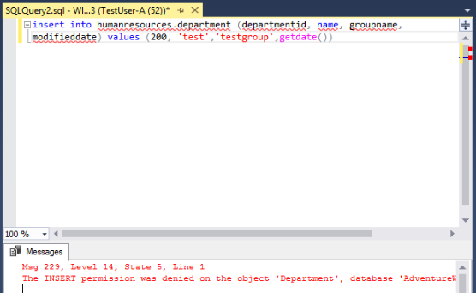

Yes, it does fail. It fails because TestUser-A doesn’t have the permission to write in the AdventureWorks2016CTP3 database, because we added TestUser-A to the *denydatawriter* role. When we execute the code, SSMS denies the execution of the code because of the permissions of TestUser-A.

10) Does it fail? Show the result in a screenshot. Describe your observation and explain why it fails.

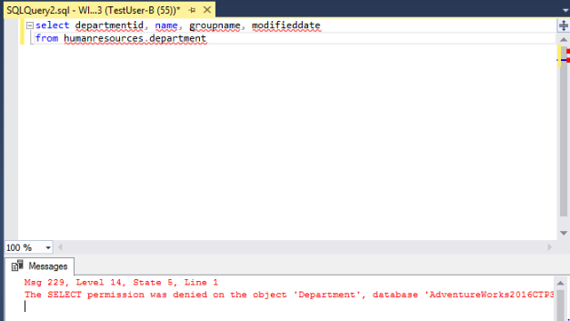

Yes, it does fail. It fails because TestUser-B doesn’t have the permission to read in the AdventureWorks2016CTP3 database, because we added TestUser-B to the *denydatareader* role. When we execute the code, SSMS denies the execution of the code because of the permissions of TestUser-B.

# Task #5. Creating a Custom Database Role

## A. Creating a custom database role

## B. Verifying results

4) Does it work? Show the result in a screenshot. Describe your observation and explain why it works.

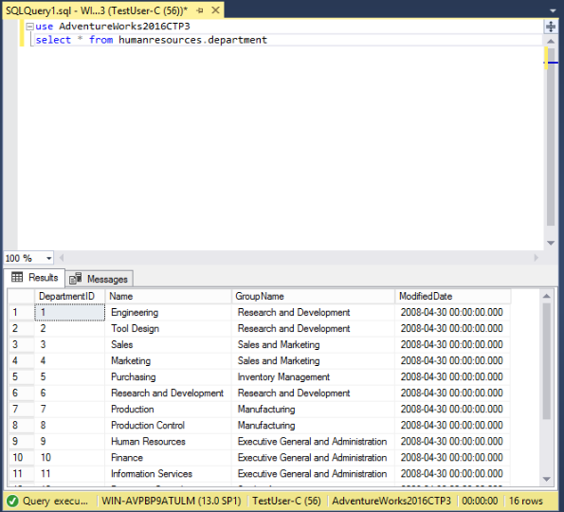

Yes, it does work. It works because TestUser-C was given the SelectOnly role. The role gives the login select only permission for the AdventureWorks2016TCP3 database.

5) Does it fail? Show the result in a screenshot. Describe your observation and explain why it fails.

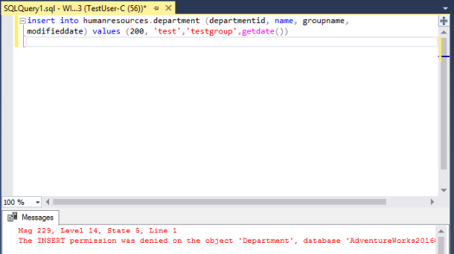

Yes, it does fail. It fails because TestUser-C was granted the select access only. No other access was given to this account therefore, the INSERT permission was denied.

# Task #6. Creating an Application Role

## A. Creating an Application Role

## B. Verifying Results

2) Does it fail? Show the result in a screenshot. Describe your observation and explain why it fails.

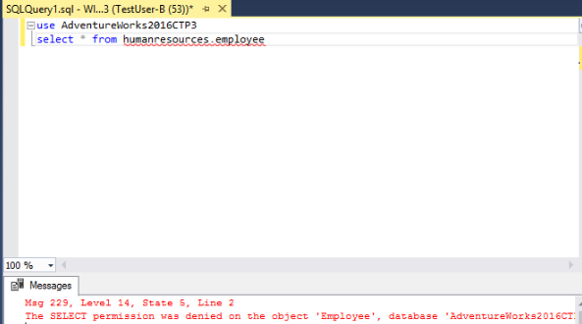

Yes, it does fail. It fails because, only the humanresources.department table was given the application role. The application role will not work on other tables, that’s why is won’t work for the humanresources.employeee table.

4) Does it work? Show the result in a screenshot. You have to click on Results to view the results. Describe your observation and explain why it works.

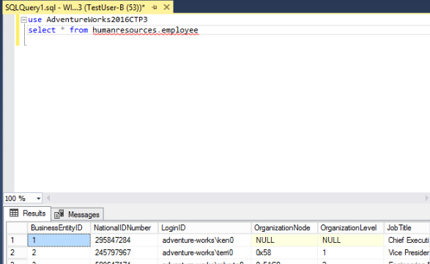



It works after activating the application role. The results have shown after running the query, but there was an error message that says the current user account was invoke with SETUSER or SP_SETAPPROLE, and changing the database is and not allowed. But, since I activated the application role for the humanresources.employee table, the table was displayed. Overall, the query ran successfully.

# Task #7. Assigning Permissions

9) Does it work? Show the result in a screenshot. Describe your observation and explain why it works.

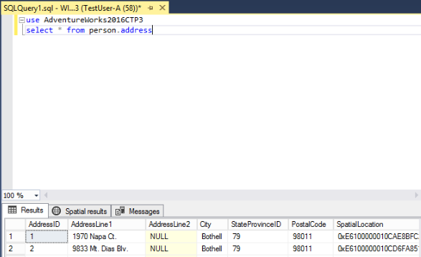

Yes, it does work. It works because, TestUser-A was granted SELECT permission for the person.address table. The results were displayed because of the granted permission for TestUser-A.

13) Run the previous query. Show the result in a screenshot. Describe your observation and explain why it fails.

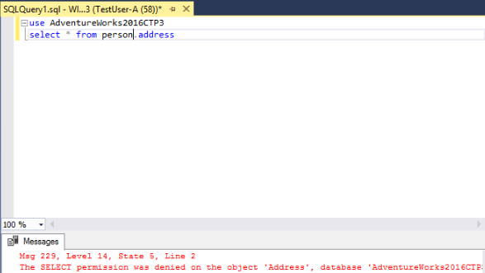

It fails because, I unchecked the select permission. Therefore, the TestUser-A no longer has permission

to select from this database so, the query will not run.

15) Run the previous query. Show the result in a screenshot. Describe your observation and explain why it works.

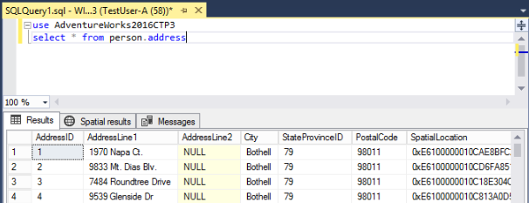

It works because, TestUser-A has access to read from the entire Adventure Works database since I granted it the db_datareader role.

19) Run the previous query. Show the result in a screenshot. Describe your observation and explain why it fails.

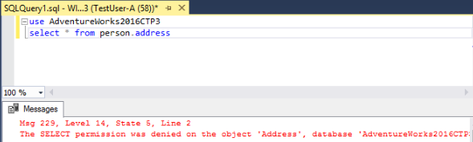

It fails because, I denied TestUser-A from using the SELECT permission. TestUser-A is denied permission to select from this database so, the query will not run.